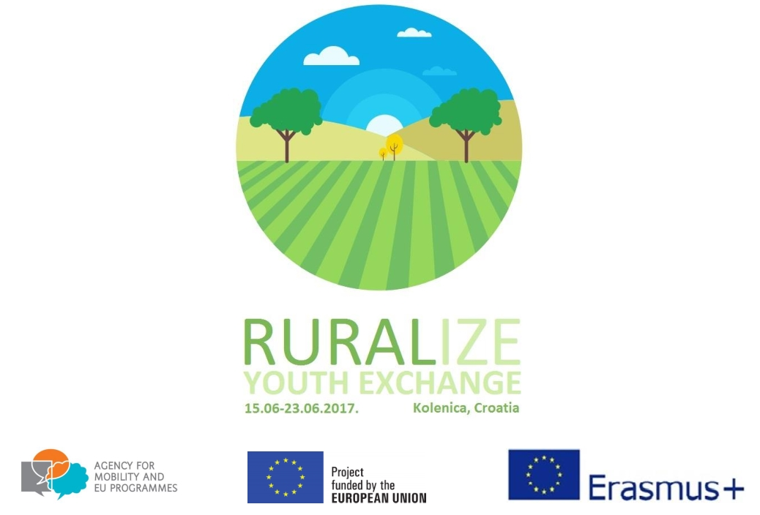

PARTICIPANT APPLICATION FORM
„Ruralize“
Kolenica, Croatia, 15.06.2017.- 23.06.2017.

Please send this questionnaire back filled in English to udruga.za.osmijeh.smb@gmail.com

sending organization
Title
City/Town, Country
PERSONAL DETAILS
First name:
Last name:
Gender: | male female (double click on box, than choose “checked”)
Place of residence:
Passport/ID number and date of validity:
Do you have the European health insurance card or any other type of health insurance suitable for Croatia?
Profession:
Please describe your occupational status (unemployed, in education, in training, employed, etc.):

Date of birth (dd/mm/yyyy):
Contact phone :
Email:
Facebook :
Special skills:
Special requirements (allergies, medical conditions, disabilities, etc.):
Food: | vegetarianvegan non-vegetarian

Official workshop language will be English. Please define your language abilities:
Language Level: |  | fluent | good | medium | basic | poor
English:

Do you have any kind of obstacles? If yes, please check the box below.
Geographical obstacles
Social obstacles
Economical obstacles
Other obstacles
None

- List top three EU countries with the biggest unemployment rate in the rural area.

______________________________________________________________________________________________________________________________________________

- In your opinion, what are the main obstacles to rural development?

_____________________________________________________________________________________________________________________________________________________________________________________________________________________

- Do you know any initiatives carried out by the EU to help rural areas?

_____________________________________________________________________________________________________________________________________________________________________________________________________________________

- What kind of business is the most likely to succeed in the rural area? Why?

_____________________________________________________________________________________________________________________________________________________________________________________________________________________

- List 3 or more things necessary for developing rural areas in your country (e.g. better infrastructure, transport connections, etc.).

____________________________________________________________________________________________________________________________________________________________________________________________________________________________________________________________________________________________

- On a scale from 1 to 10, how would you rate your knowledge on rural areas, issues and development?

_______________________________________________________________________

Tell us about your personal motivation and expectations regarding this youth exchange.

Any additional comments or ideas?

If chosen to participate in this youth exchange, do you agree to actively participate in preparation acitivites and all project workshops as well as help us to ensure project visibility and disseminate project results?
YES NO

Thank you and good luck!

